

**Project Report**

**KEANSBURG PARK**

GROUP MEMBERS

Mr: AHMED KHAN

&

Mr: SHEHROZ

CONTENTS

………......INTRODUCTION…………….

1. Definatin of the problem.
2. Requirement Analysis .
3. Design Phase .
4. Sourse Code.

Introduction

The thirst for learning, upgrading technical skills and applying the concepts in real life environment at a fast pace is what the industry demands from IT professionals today. However busy work schedules, far-flung locations, unavailability of convenient time-slots pose as major barriers when it comes to applying the concepts into

realism. And hence the need to look out for alternative means of implementation in the form of laddered approach.

The above truly pose as constraints especially for our students too! With their busy schedules, it is indeed difficult for our students to keep up with the genuine and constant need for integrated application which can be seen live especially so in the field of IT education where technology can change on the spur of a moment. Well,technology does come to our rescue at such times!!

Keeping the above in mind and in tune with our constant endeavour to use

Technology in our training model, we at Aptech have thought of revolutionizingthe way our students learn and implement the concepts using tools themselves by providing a live and synchronous eProject learning environment!

1. Definatin of the problem.

Keansburg Park is now prime focus of the city and nation. It is made by Gottlieb

groups of companies. The development of this park took 5 years to get their desired

finished product. It has become nation pride now. The area of theme park is about

45 acre land. The Management has put all the efforts to keep the attractions

operational. The Keansburg Park management wants you to develop the website of

the park which should include describing all the attraction of the park and also allow

the user to book the ticket online.

1. Requirement Analysis .

* The website must be designed with beautiful color combination with all the
* required links defined properly. Also all the section of the website must be
* defined properly.
* 2) Different Zones and attraction, Restaurants, Entertainment, Tickets and
* Prices, Gallery should be presented.
* 3) Prices value must be show the differences as per the day (like weekend or
* weekday or family pack).
* 4) About us, Contact Us, Disclaimer must be included.
* 5) Creating an account facility can also be added.
* 6) Dummy procedure for booking the ticket can be added.
* 7) Navigation of the project must be made smooth.
* 8) Visitor reviews and ratings should be captured.
* 9) Gallery can be added for viewing different images.
* 10) Site map, Gallery, about us, Queries link, Contact us link must be added.
* 11) About Us and Contact Us: This menu option should display Email id, address,
* and contact number of the organization who is developing the system.

1. Design Phase . Home Page
2. Navbar



1. Secound Navbar



1. Hover Pages Drop Downs

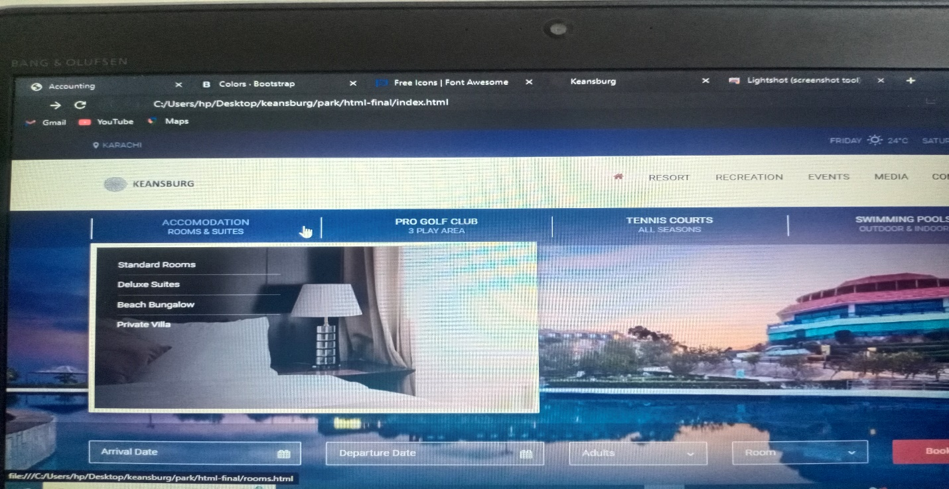

1. Book Rooms



1. Banners Desighn

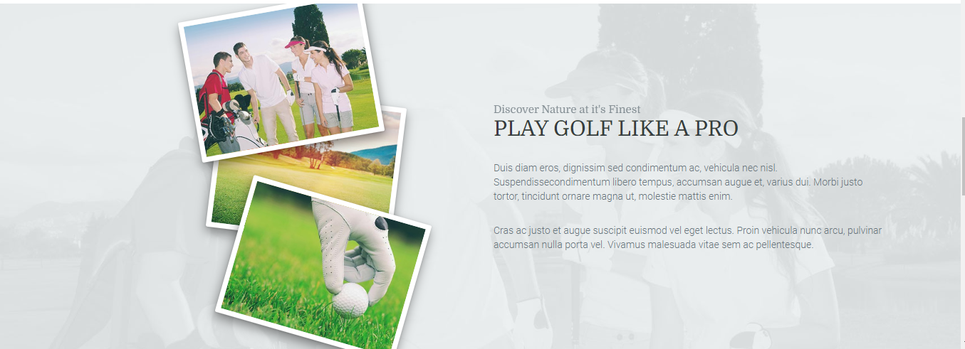

1. Sliders

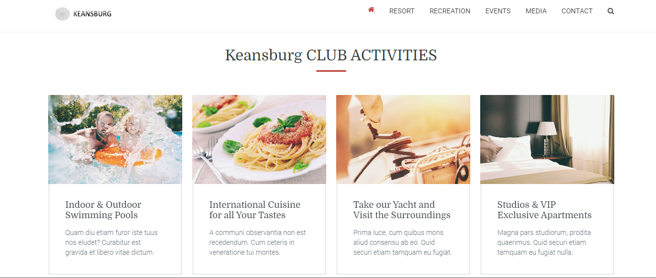

1. Footer

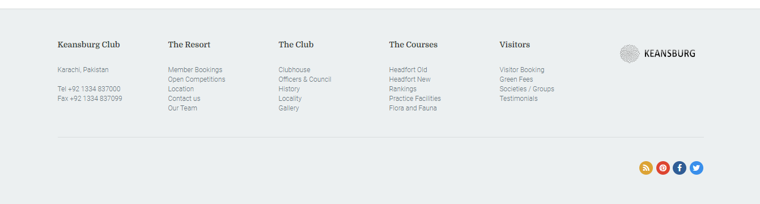

1. Resort Page

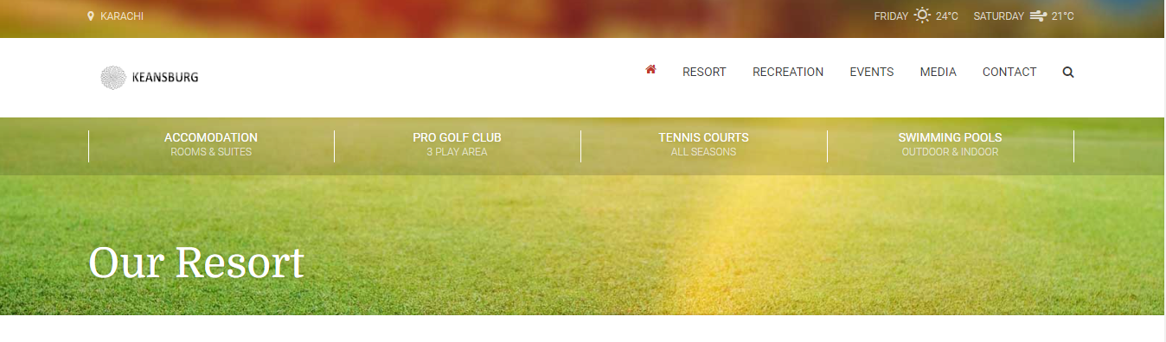

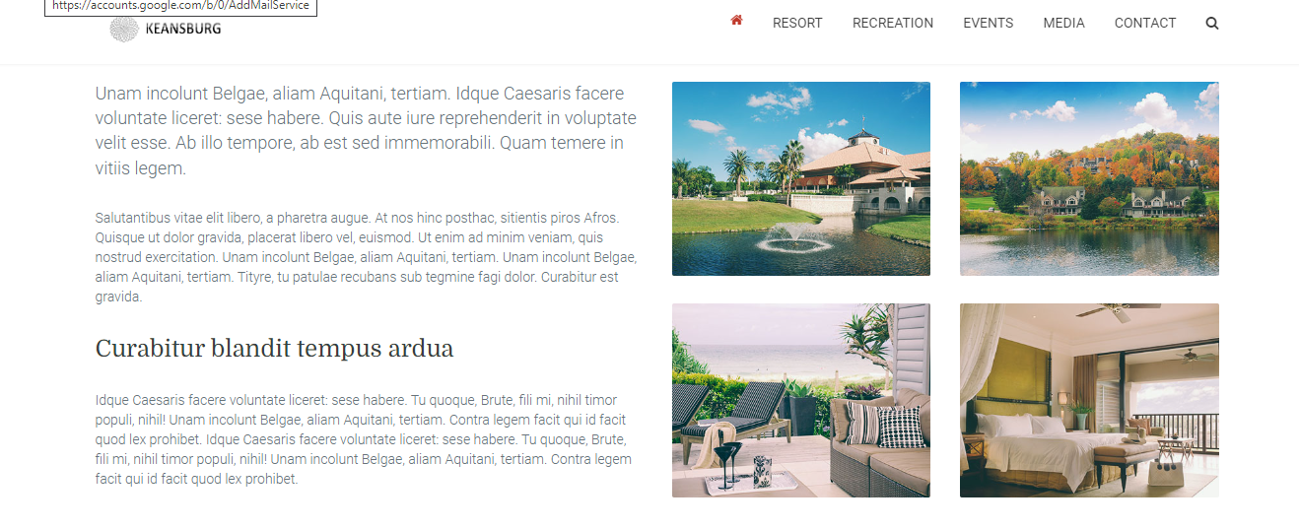

1. Resort drop down Single Room

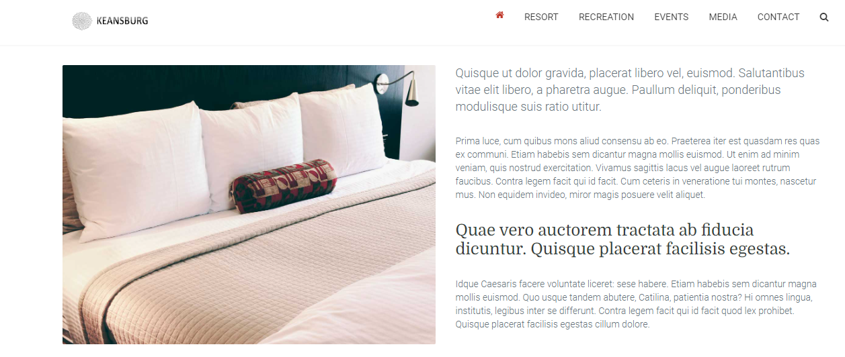

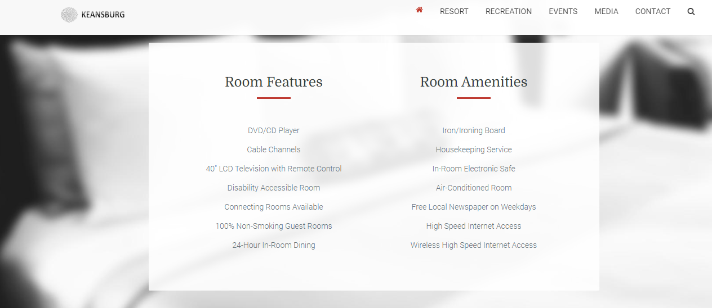

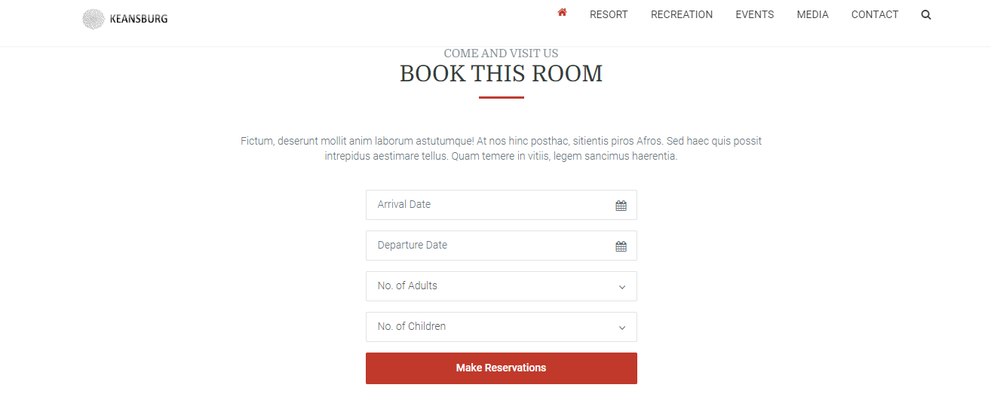

1. Resort Dinnig Page

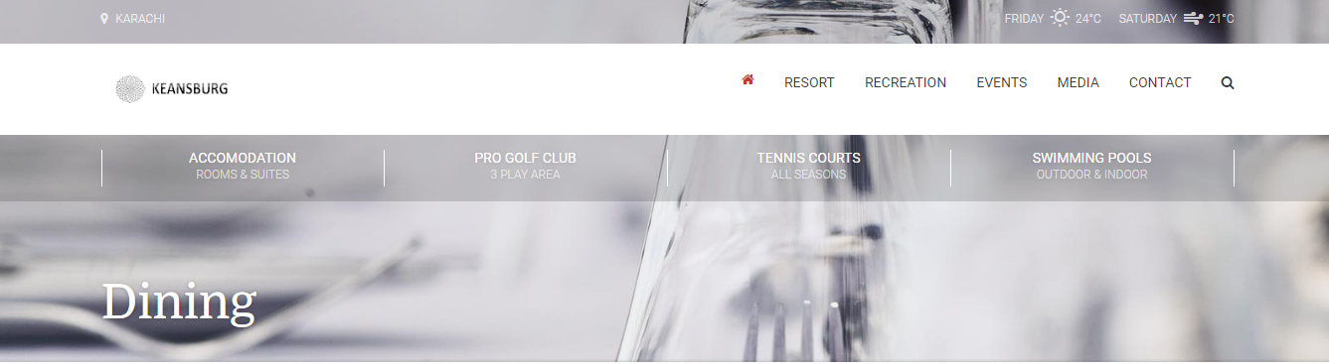  
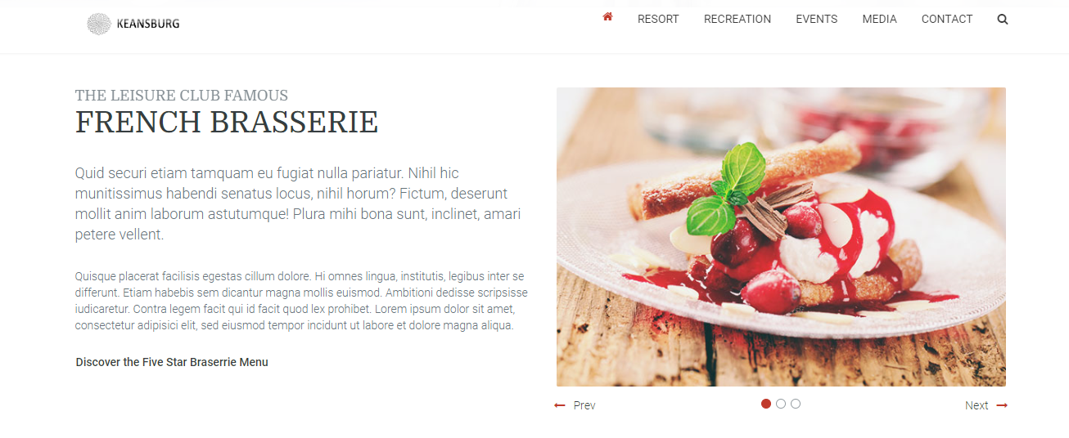

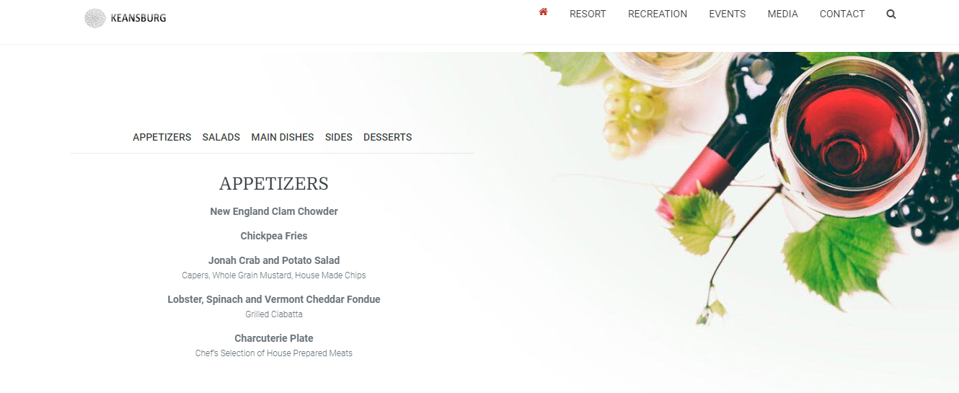

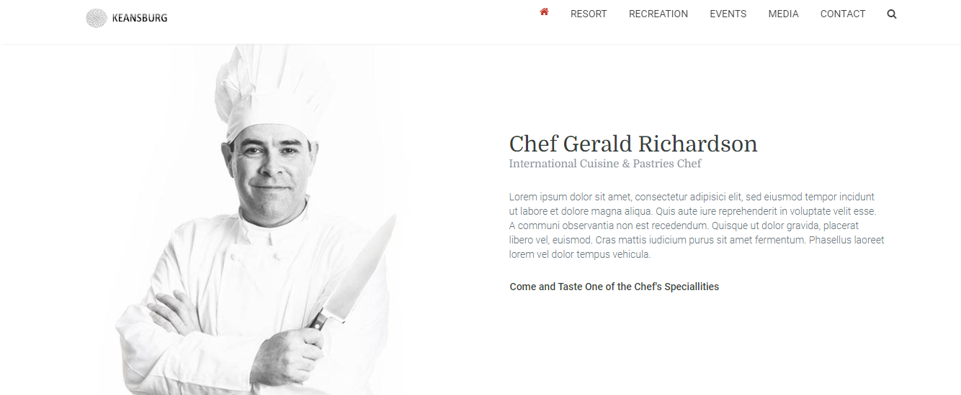

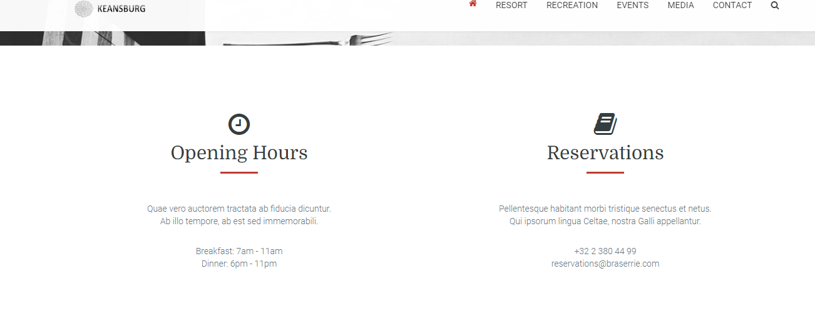

1. Recration Page

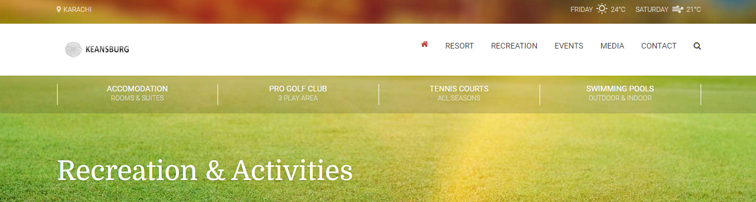

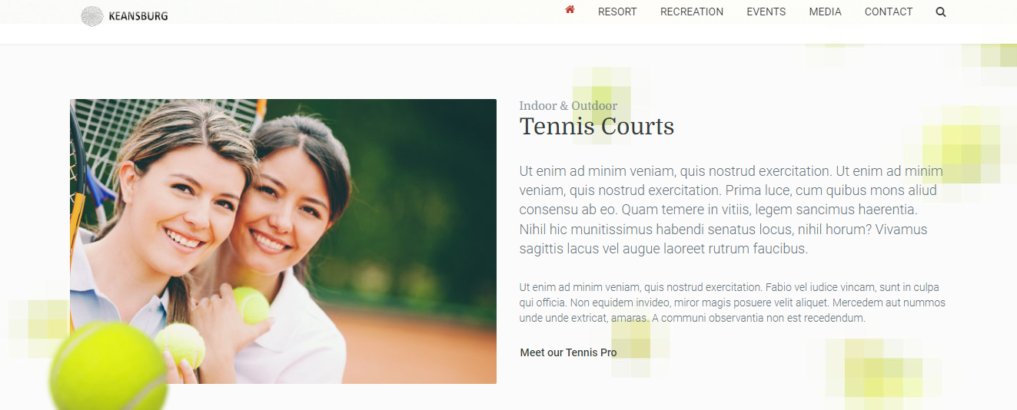

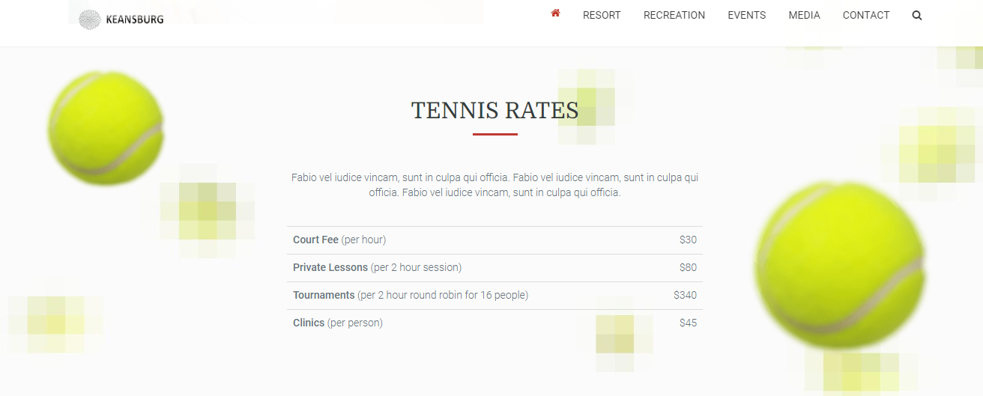

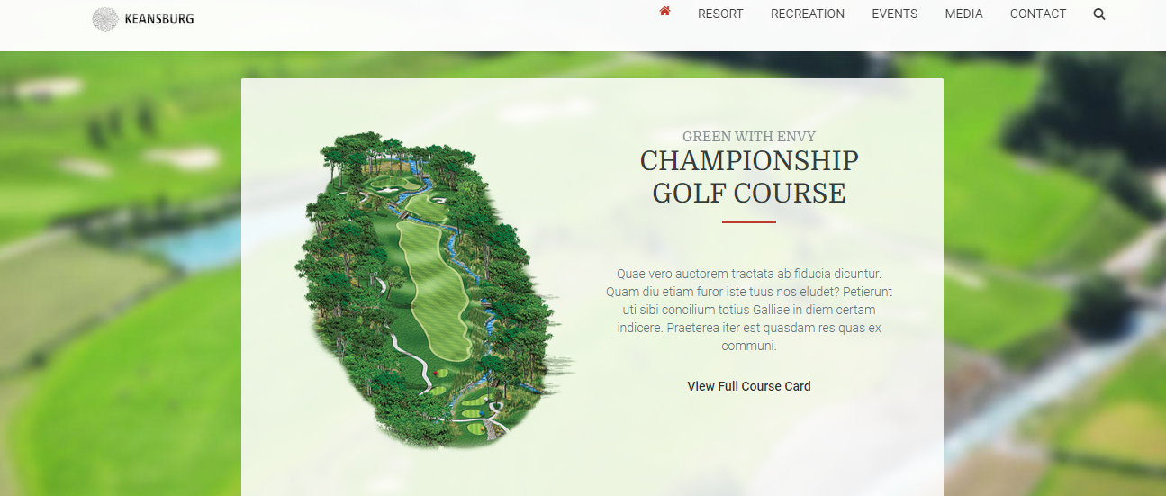

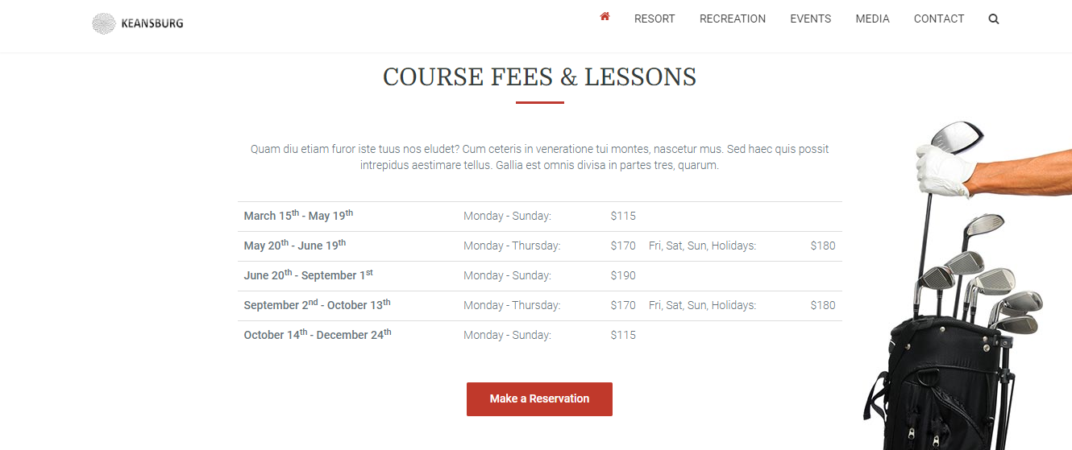

1. Events Page

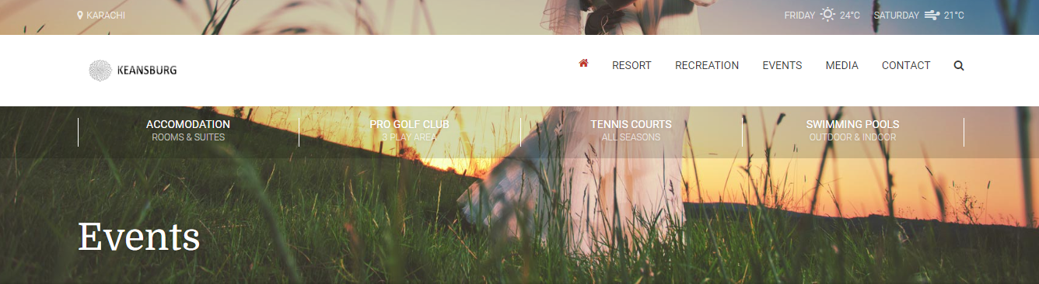

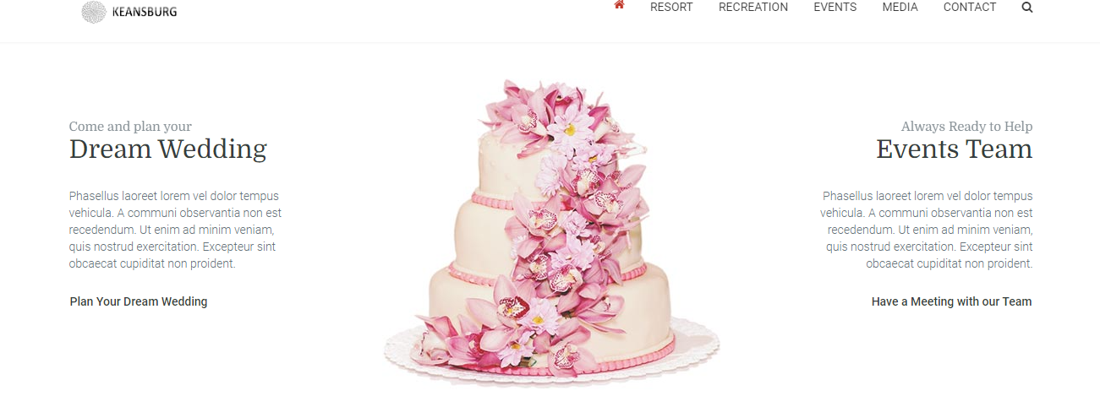

1. Media page

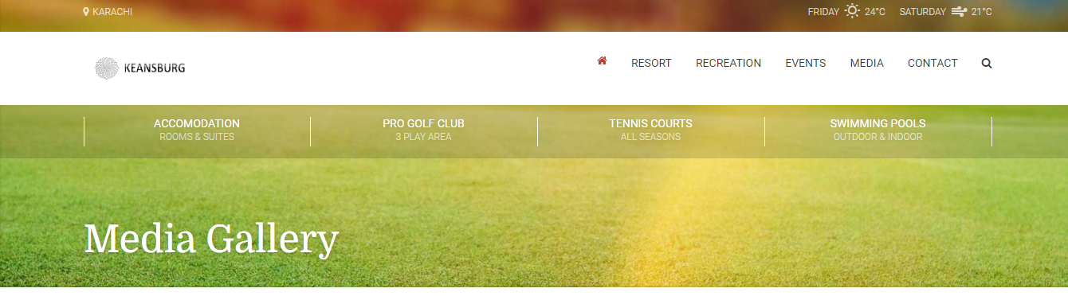

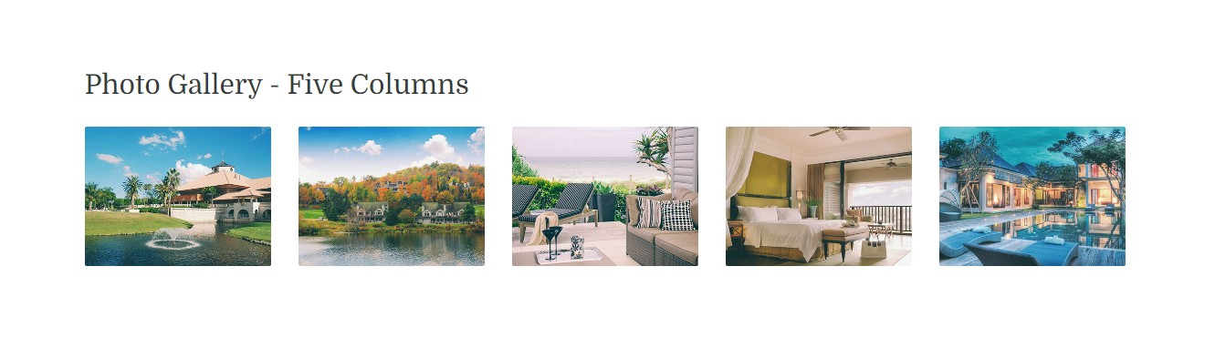

1. Pricing Table

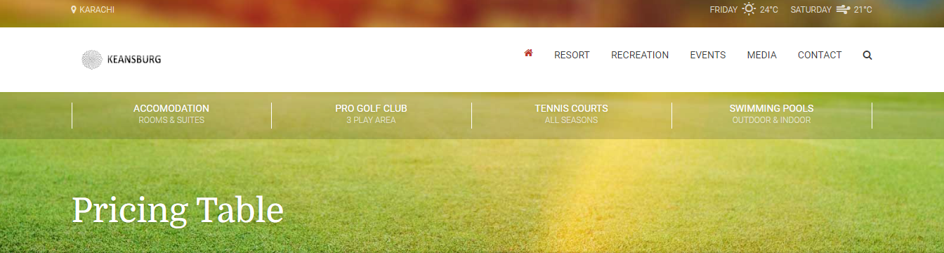

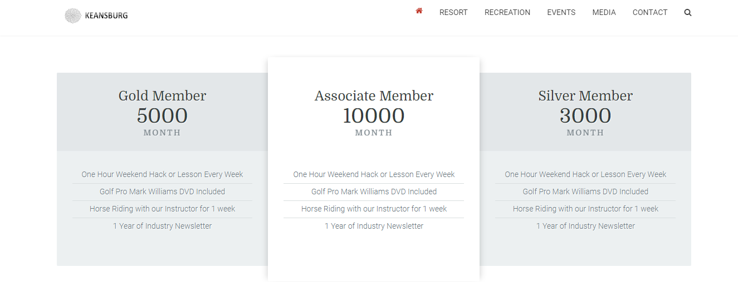

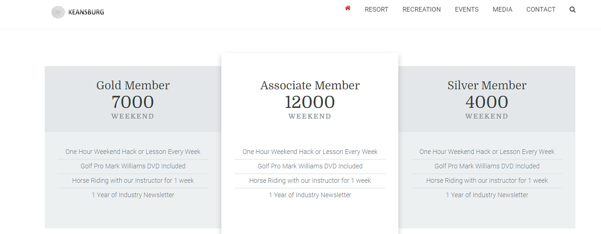

1. Contact Page

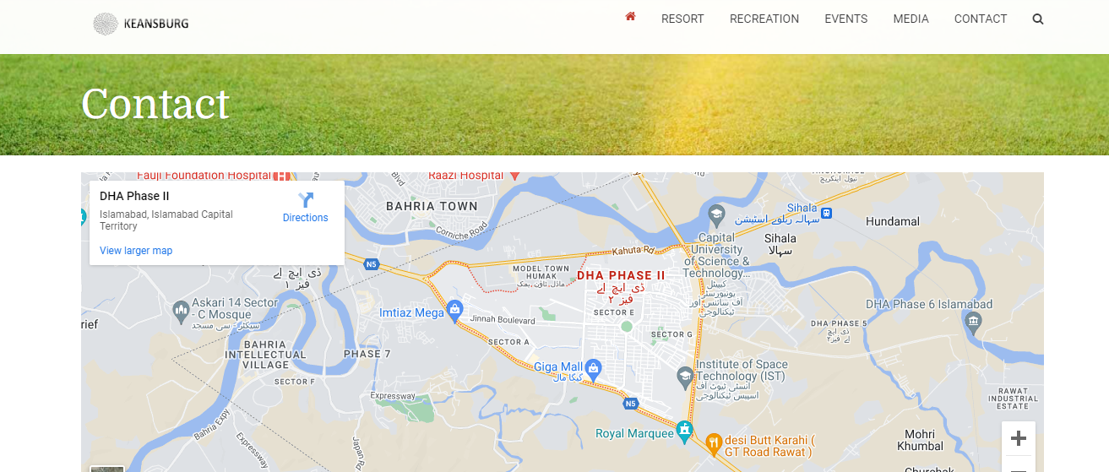

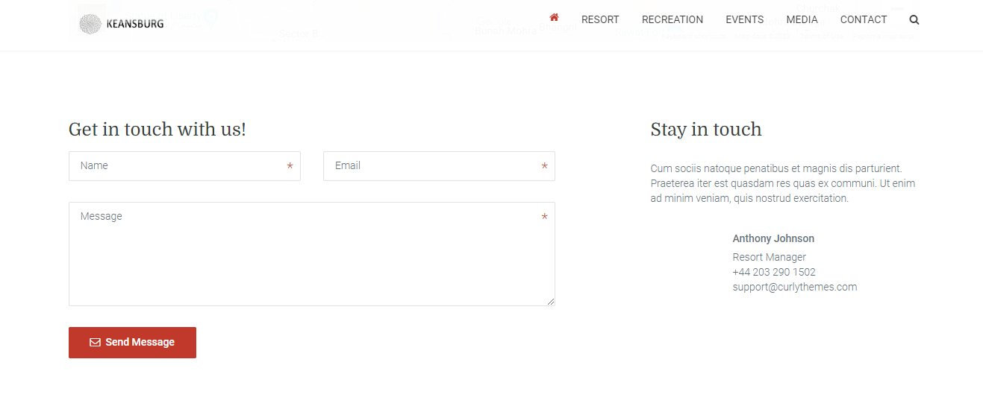

1. Drop Down Pages Rooms / Standerd Rooms

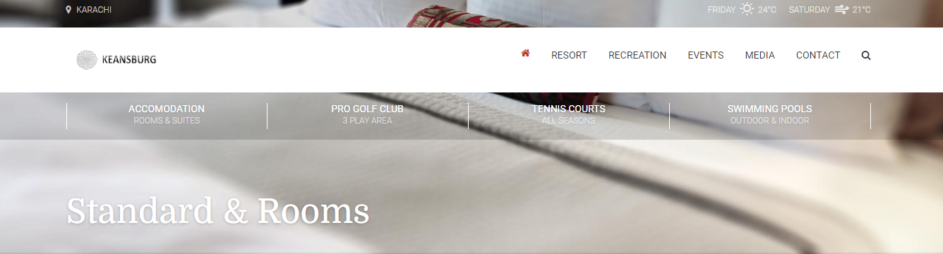

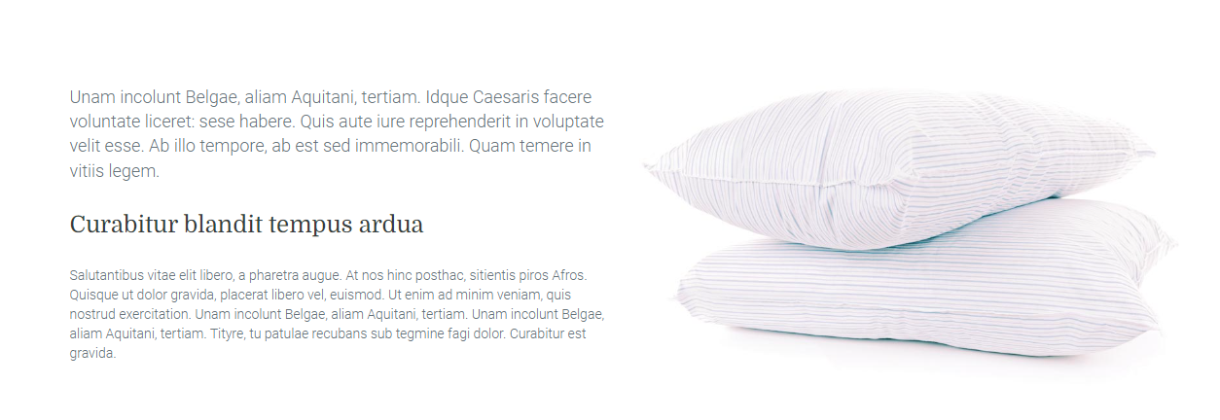

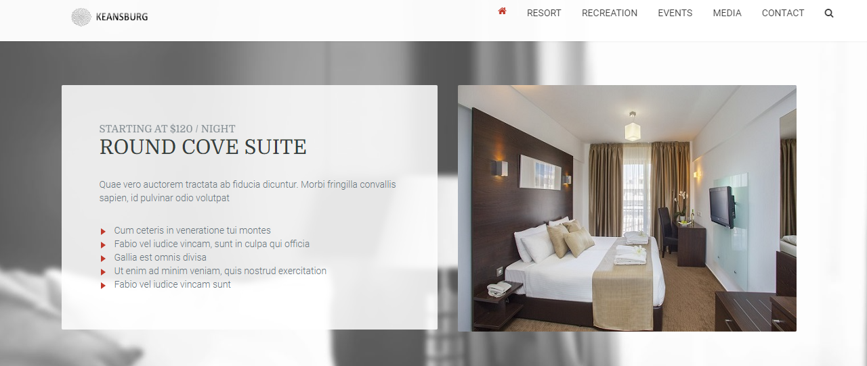

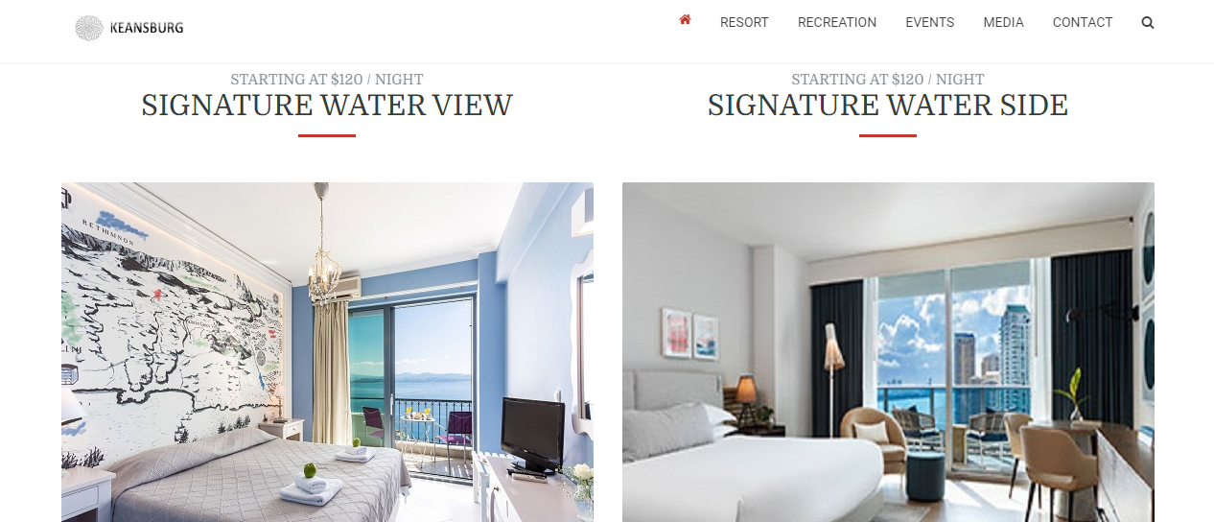

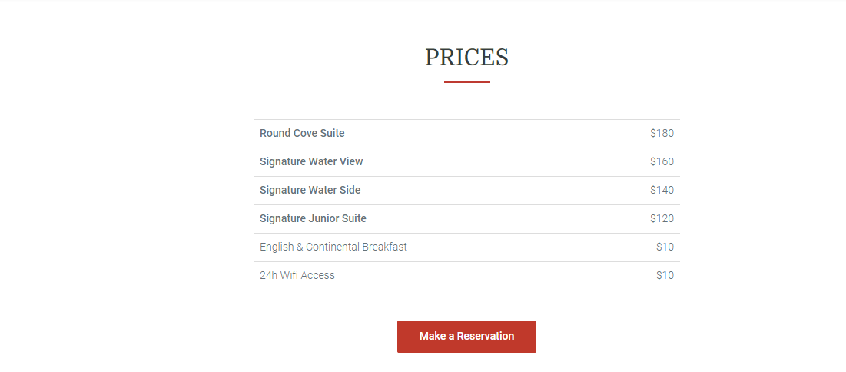

1. Drop Down Pages Rooms / Golf

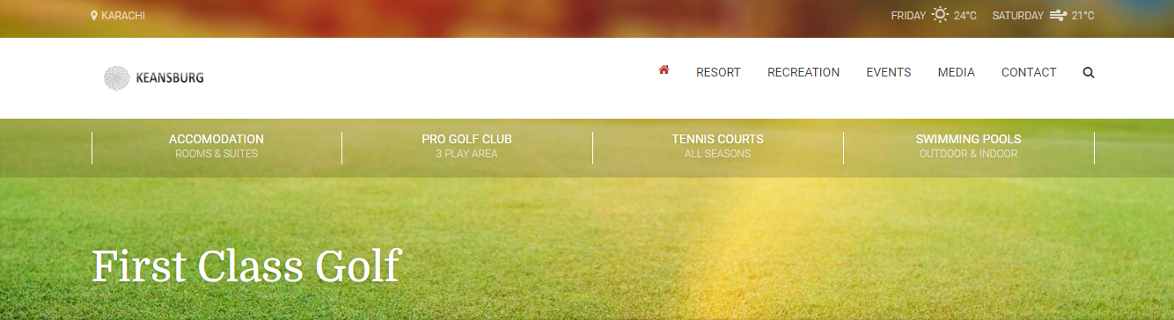

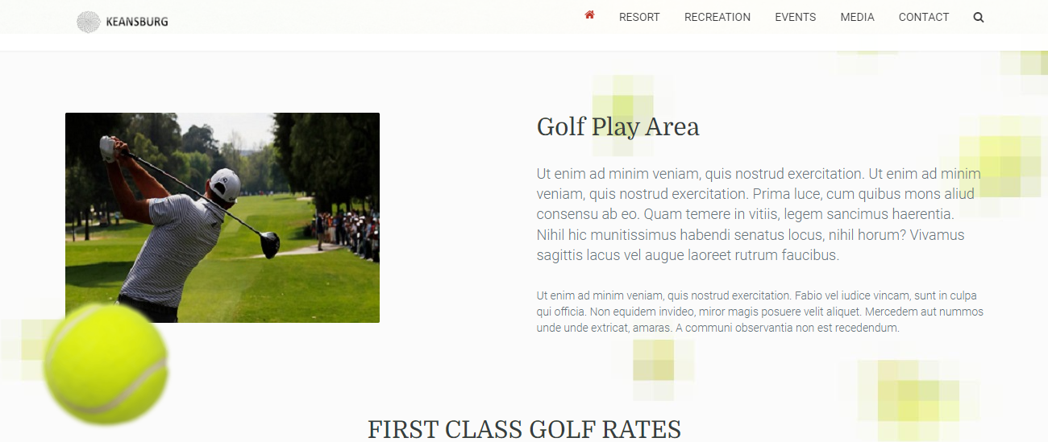

1. Drop Down Pages Rooms / Tennis

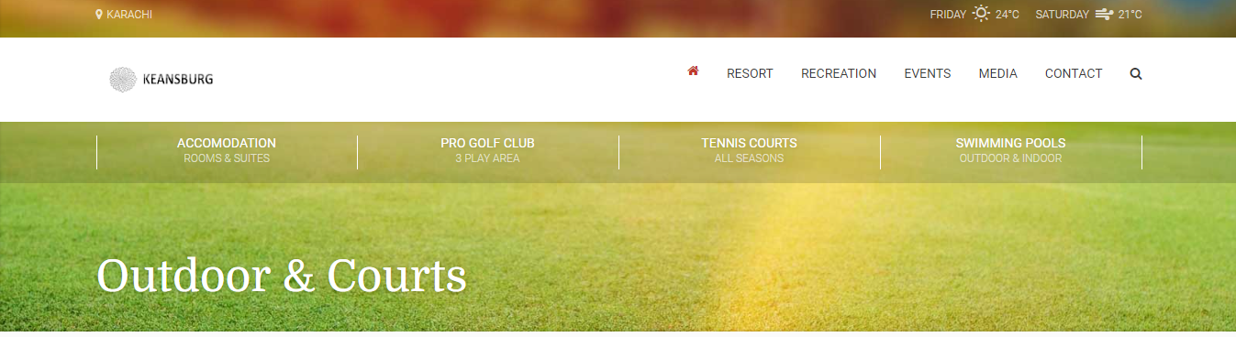

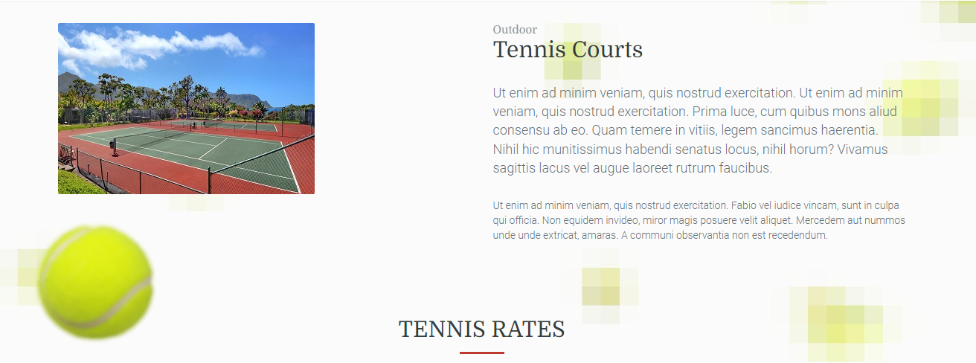

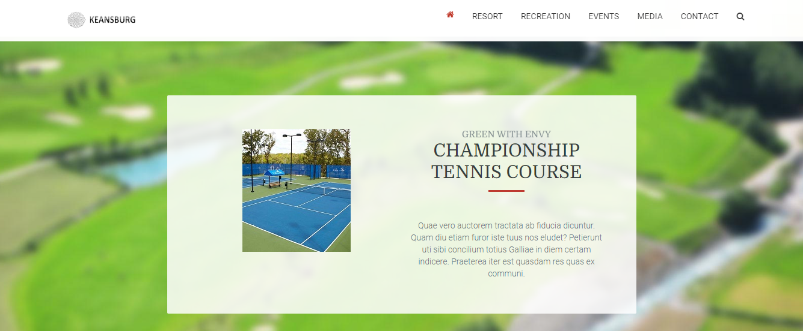

1. Drop Down Pages / Swimming Pools

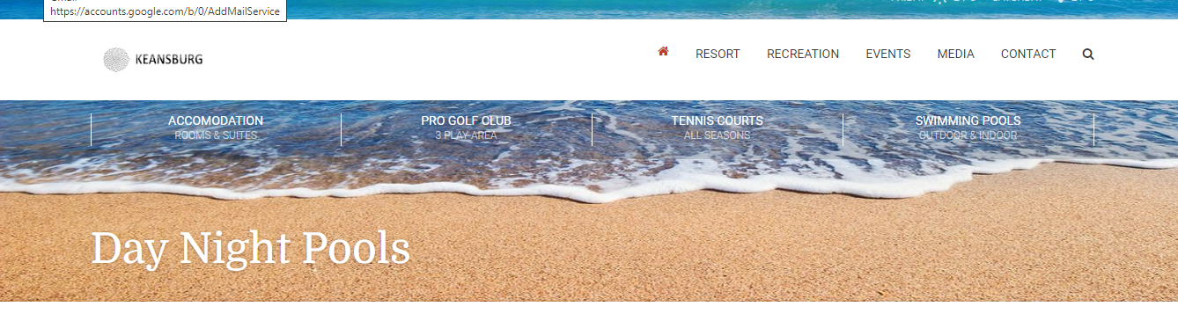

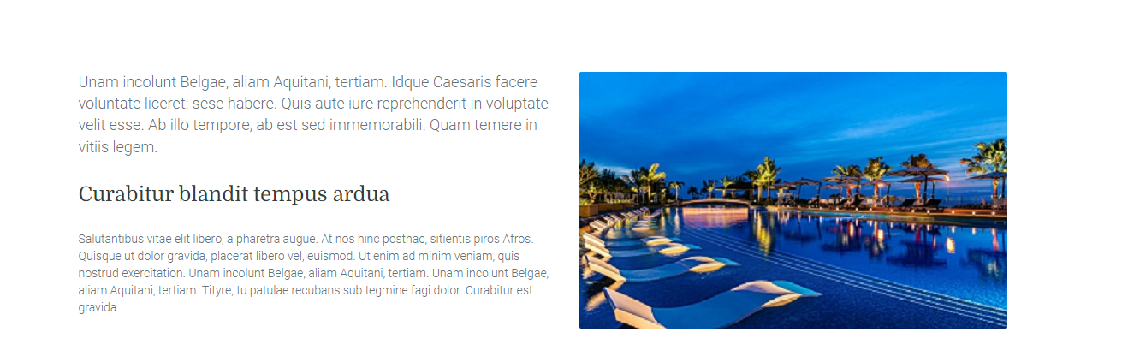

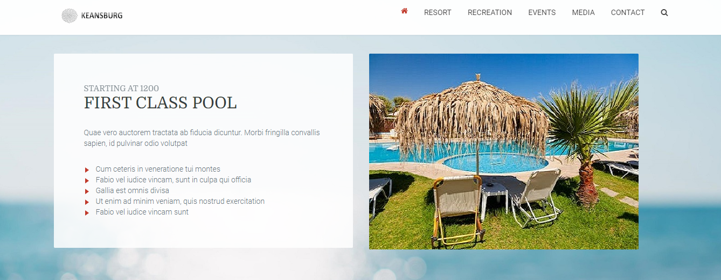

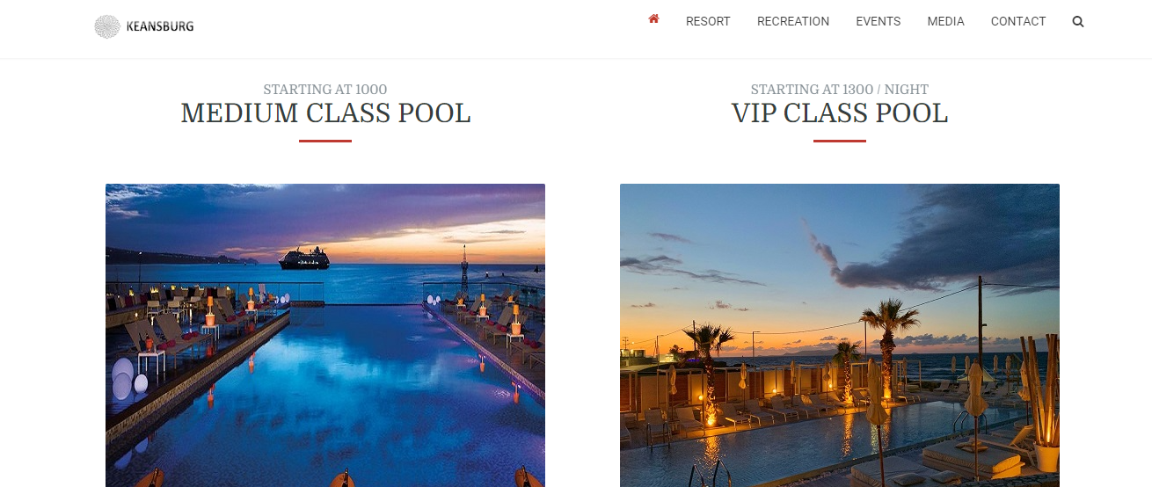

1. Source Code

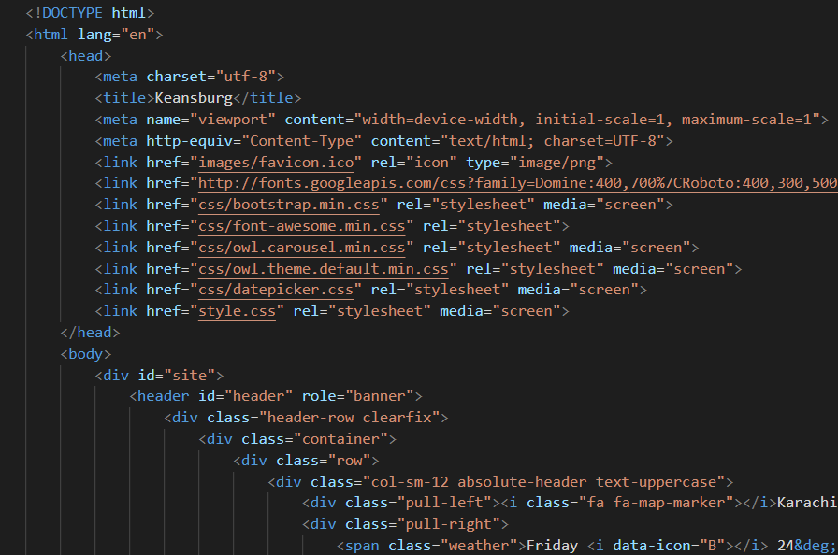

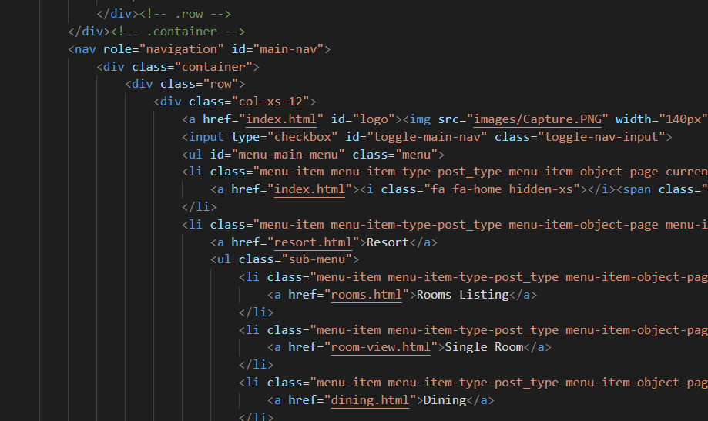

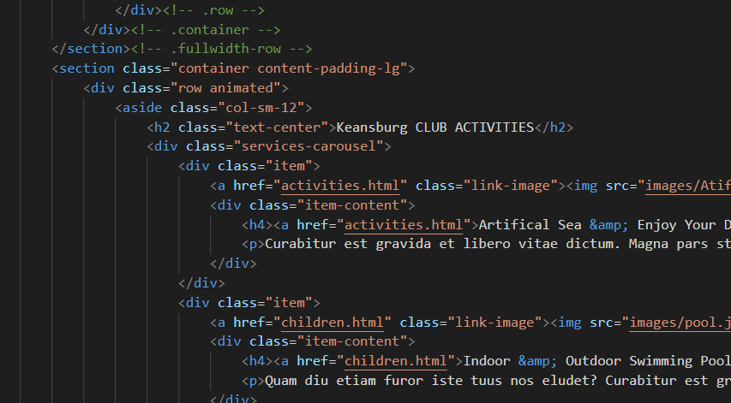

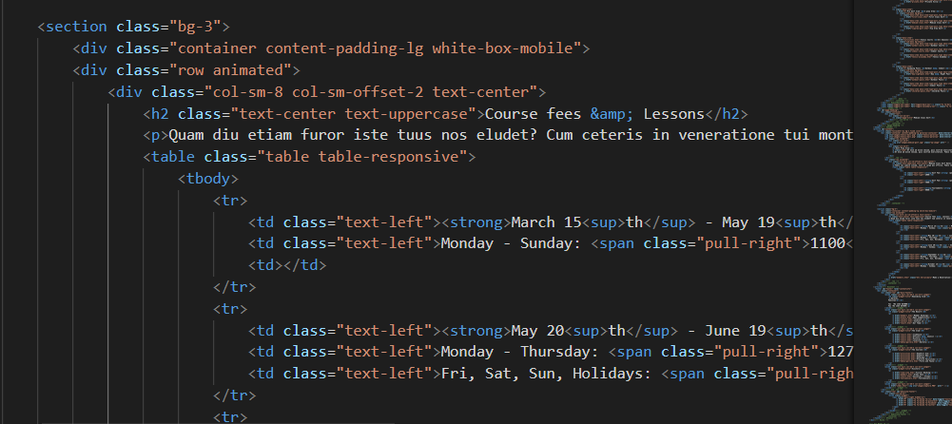

..THANK YOU..